Guide from Brady: https://confluence.corp.netsuite.com/display/~brady.onkka/Google+Analytics+4
If the GA id has the UA: GA3
If it’s only numbers: GA4

Tracking tools
On GA4 we have a different layout
Press Admin -> Data Streams:
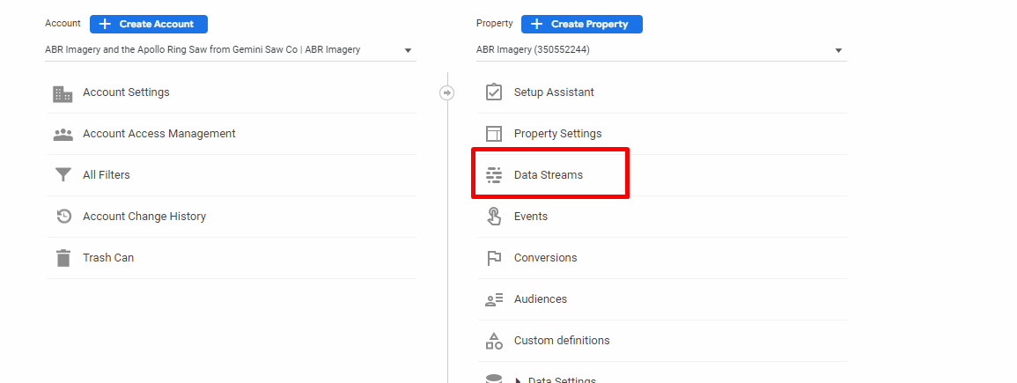
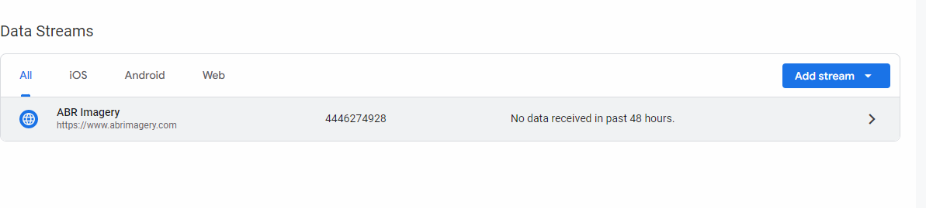
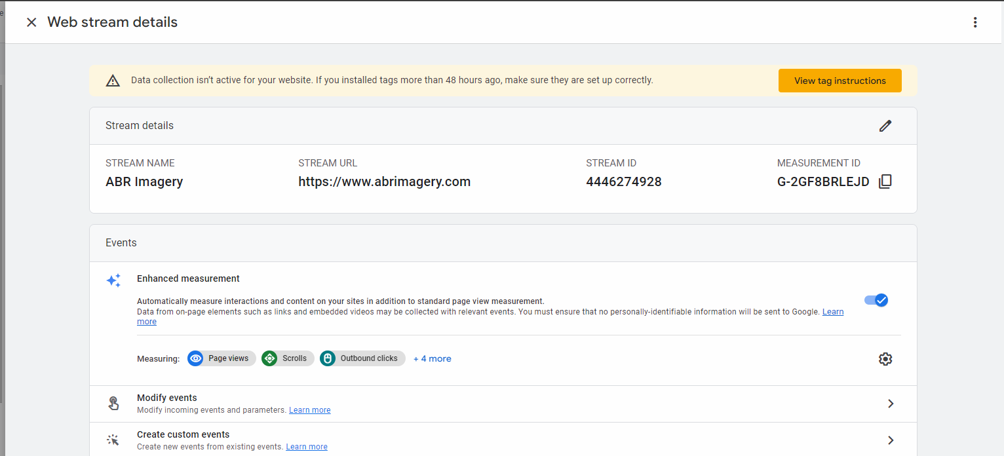
Then Setup -> Suite Commerce Advanced -> Google tag manager editor and we add GA service:
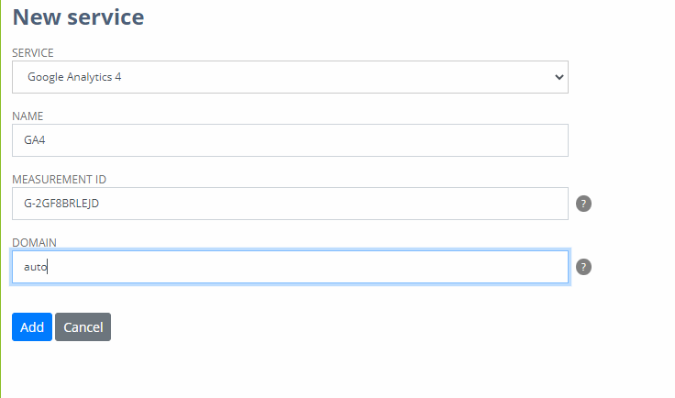
The measurement ID is what we need to link with netsuite. In the site it will show:
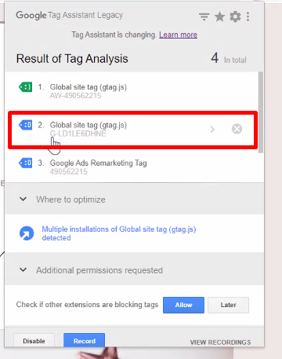
In my case, GA4 does not appear in my site abrimagery.com, but it does not matter we can make it be:

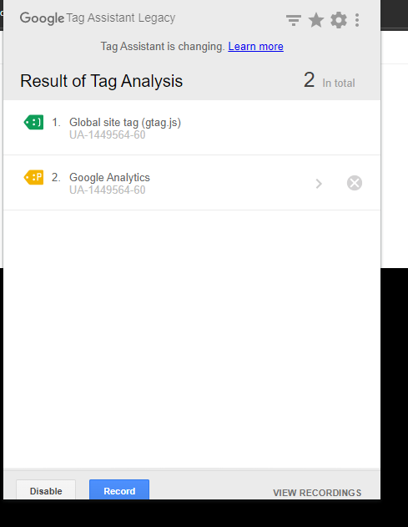
That sixty on the account means if they have a high number is most likely they have a marketing company on them.
In this case we do migration with oscraper because we do not have access with google analytics.
View settings does not appear to be in GA4, perhaps under

Exclusions list
On data stream:
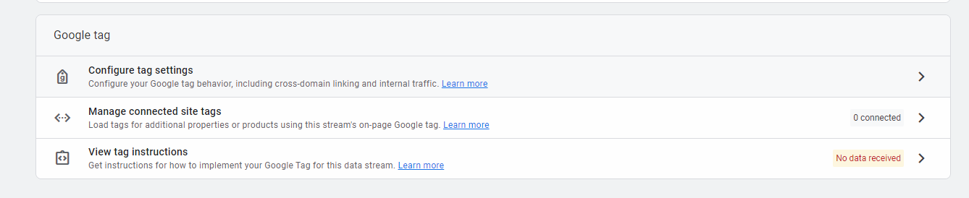
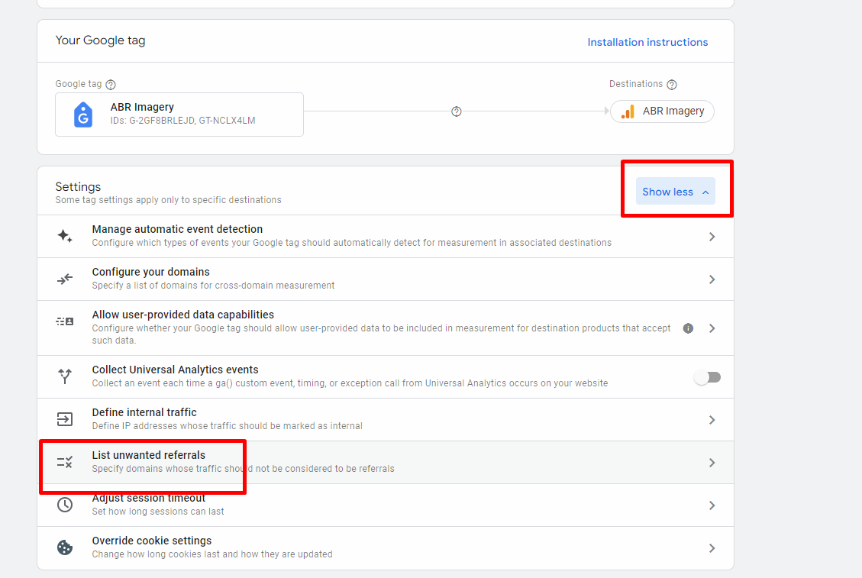
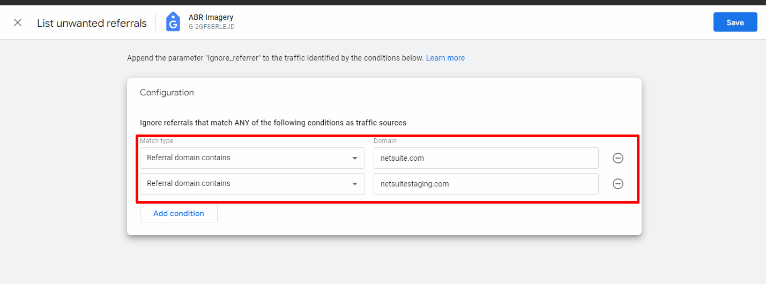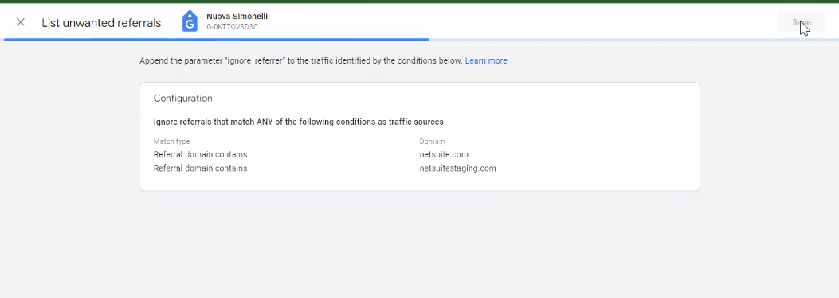

Pre Go-Live

Post Go-Live:
What you do in GA3 you do it in GA4 applicable.
Search console is asociated for GA3, we need to associate it to GA4

